innovative and powerful LogiMAT visitor magnet

Trade show success for Melkus Mechatronic due to sustained trend towards automation: The Stuttgart LogiMAT is the largest and most important intralogistics trade show in the German-speaking world. According to the organizer, it is an industry meeting of superlatives and attracted more than 65,000 visitors from March 11 to 13, 2025. Exhibitor Melkus Mechatronic is extremely pleased with the outcome of its participation.

Goeming/Salzburg, 20 March 2025 – Companies from all sectors are considering automating their intralogistics processes. As this popular trend defies the current recession, visiting LogiMAT is imperative for all intralogistics experts. "We had twice as many talks as last year and were able to impress our visitors with our wide AGV range," says Martin Lindner, CEO of Melkus Mechatronic. "Our automation concepts increase efficiency and output for our customers, and that's exactly what they need right now."

New "Melkus BLS4060" AGV
The Melkus Rack Stacker BLS4060 particularly generated a lot of interest among trade show visitors. This latest Melkus Mechatronic transport robot showed the audience what it can do in a live demonstration. It alternately transported Euro boxes and PCB magazines, picking them up or delivering them to the correct transfer point without any additional aids using its innovative lift system.
The dynamic small AGV with automated load transfer was developed for flexible use in precision mechanics or electronics production, especially for transporting PCB and small parts containers or Euro boxes. Thanks to its extremely compact design, it can be used in production environments where space is at a premium. It efficiently supports the production process.

The classic Melkus HLG120 pallet AGV was also presented live at the Melkus Mechatronic LogiMAT booth. It is ideally suited for many transport operations within a company. As many customers are primarily looking for a high level of stability in their internal processes, many visitors were particularly interested in the reliability and high availability of Melkus Mechatronic autonomous transport vehicles.

Vehicles and fleet management combined
In addition to the autonomous transport robots from Melkus Mechatronic, Sigmatek also presented the real-time localisation software SlamLoc and the open fleet management system TCS (Traffic Control System) at the joint booth.

The numerous discussions with interested parties and industry experts have provided valuable input that will be incorporated into the further development of the products. Melkus Mechatronic is very positive about the coming months. "Our participation in LogiMAT 2025 was a complete success," confirms Martin Lindner. "We are already working on our next innovations and plan to present them on a much larger stand at LogiMAT 2026."

Image Captions

The Melkus Mechatronic and Sigmatek exhibition team are delighted with LogiMAT 2025. From left: David Barth, Managing Director Martin Lindner and Karin Schweiberer from Melkus Mechatronic, Otto Koller from Sigmatek, Melkus Mechatronic founder Andreas Melkus, Gerhard Veldman from Sigmatek as well as Andreas Voichtleitner and Dominik Schnitzinger from Melkus Mechatronic.  All images: Melkus Mechatronic | 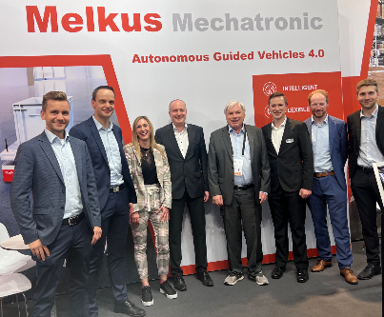
In a live demonstration at the Melkus Mechatronic booth, the Melkus Rack Stacker BLS4060 demonstrated its suitability for the space-saving, efficient transport of PCB magazines and Euro boxes, including autonomous storage and retrieval, attracting the interest of trade show visitors. | 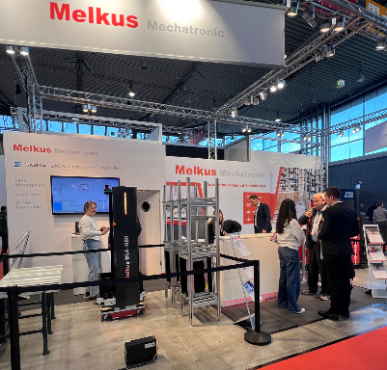
Martin Lindner, CEO of Melkus Mechatronic:  "We had twice as many discussions as last year and were able to inspire our visitors across all sectors with our AGV range. Automation is very popular and is defying the recession as it allows us to increase efficiency and output for our customers, which is exactly what is needed now." | 

About Melkus Mechatronic
Melkus Mechatronic GmbH is an innovative technology company based in Salzburg. With more than ten years of experience in the field of AGVs and mobile robotics, it provides customers with highly available AGVs for flexible in-house transport with maximum reliability. Swiftly installed and commissioned, these enable Melkus operators to organise their intralogistics more efficiently and to establish resource-saving processes. Melkus employs highly qualified and committed staff and offers a range of six AGVs for a wide variety of applications. www.melkus-mechatronic.com

